**Compiler Design (CSE-425) LAB**

**Assignment- 1**

Group Members:

Patil Shrivardhan Chandrakant – 20074037

Aaditya Kumar Rai – 20074038 Vanshika Kejriwal – 20074039

i) Source code:

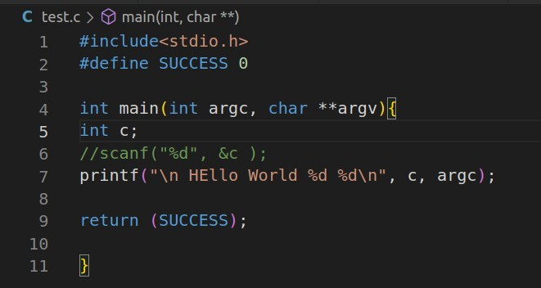

Command run:

gcc -Wall --verbose --save-temps -o first-exec test.c

Console Output:

Preprocessor file:

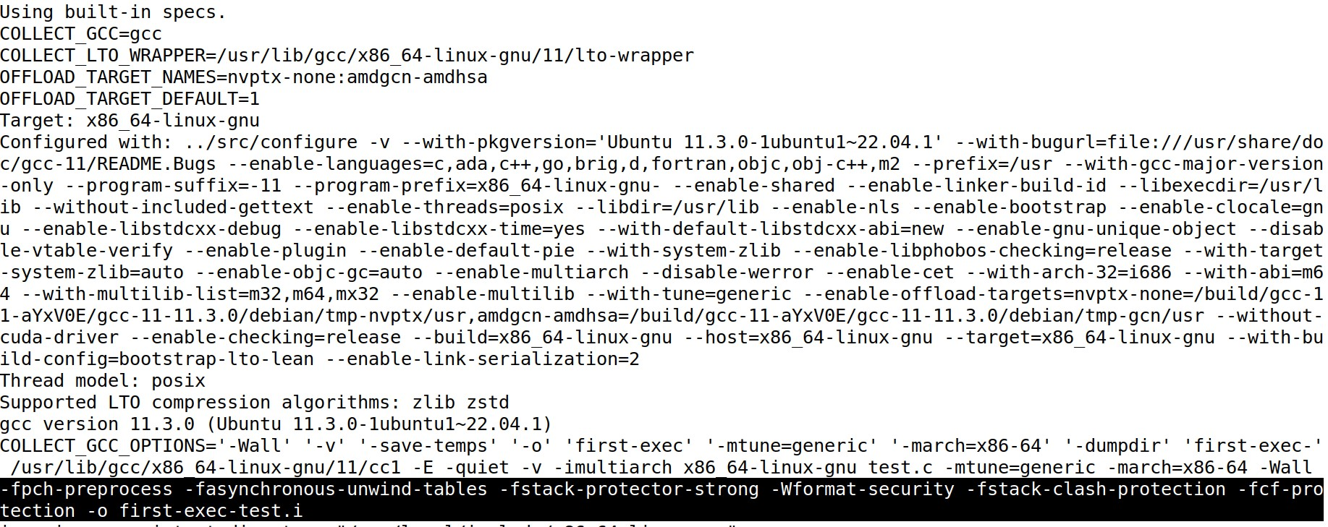

first-exec-test.i file contents:

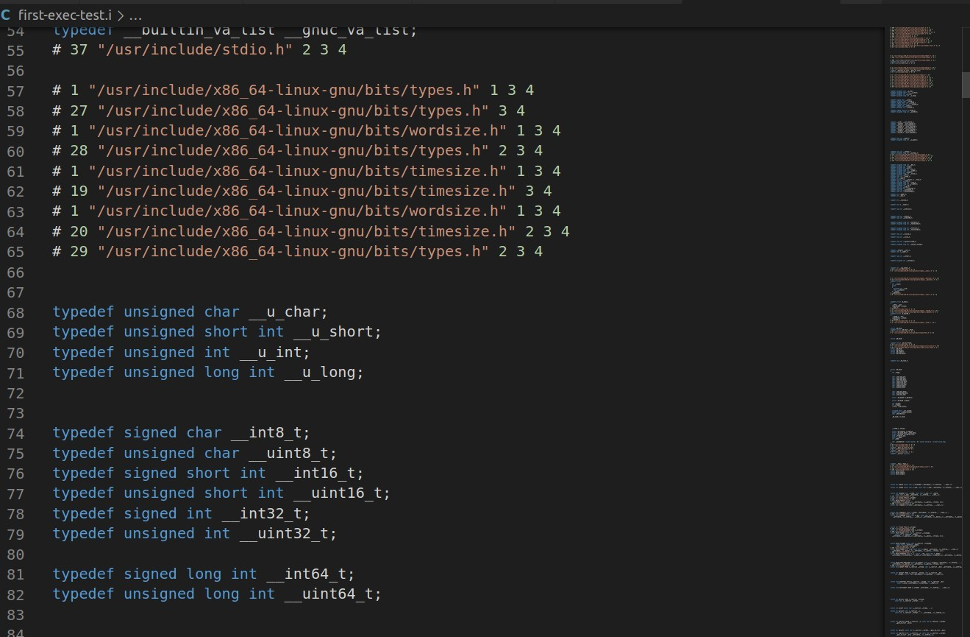

Compiler file (.s):

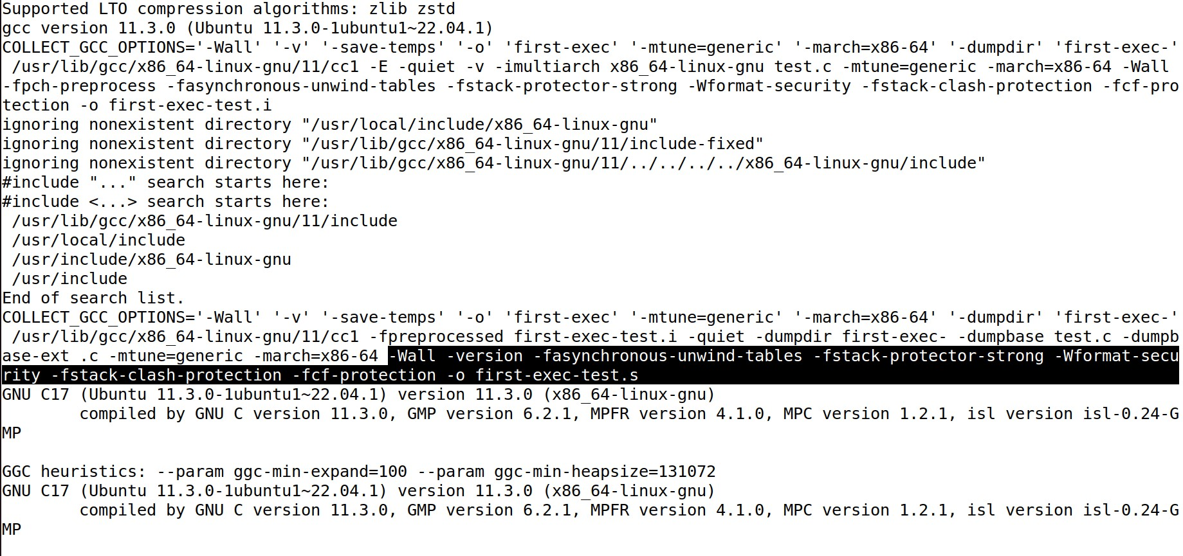

Contents of first-exec-test.s file:

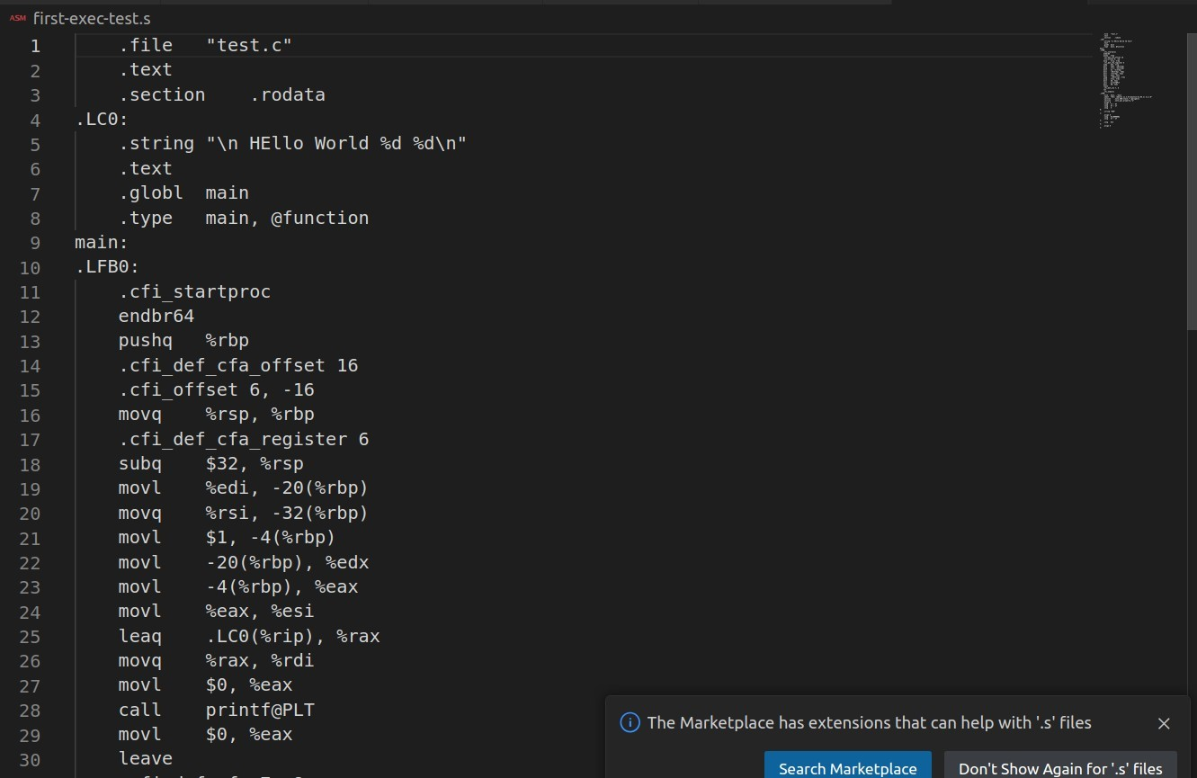

Assembler file (.o)

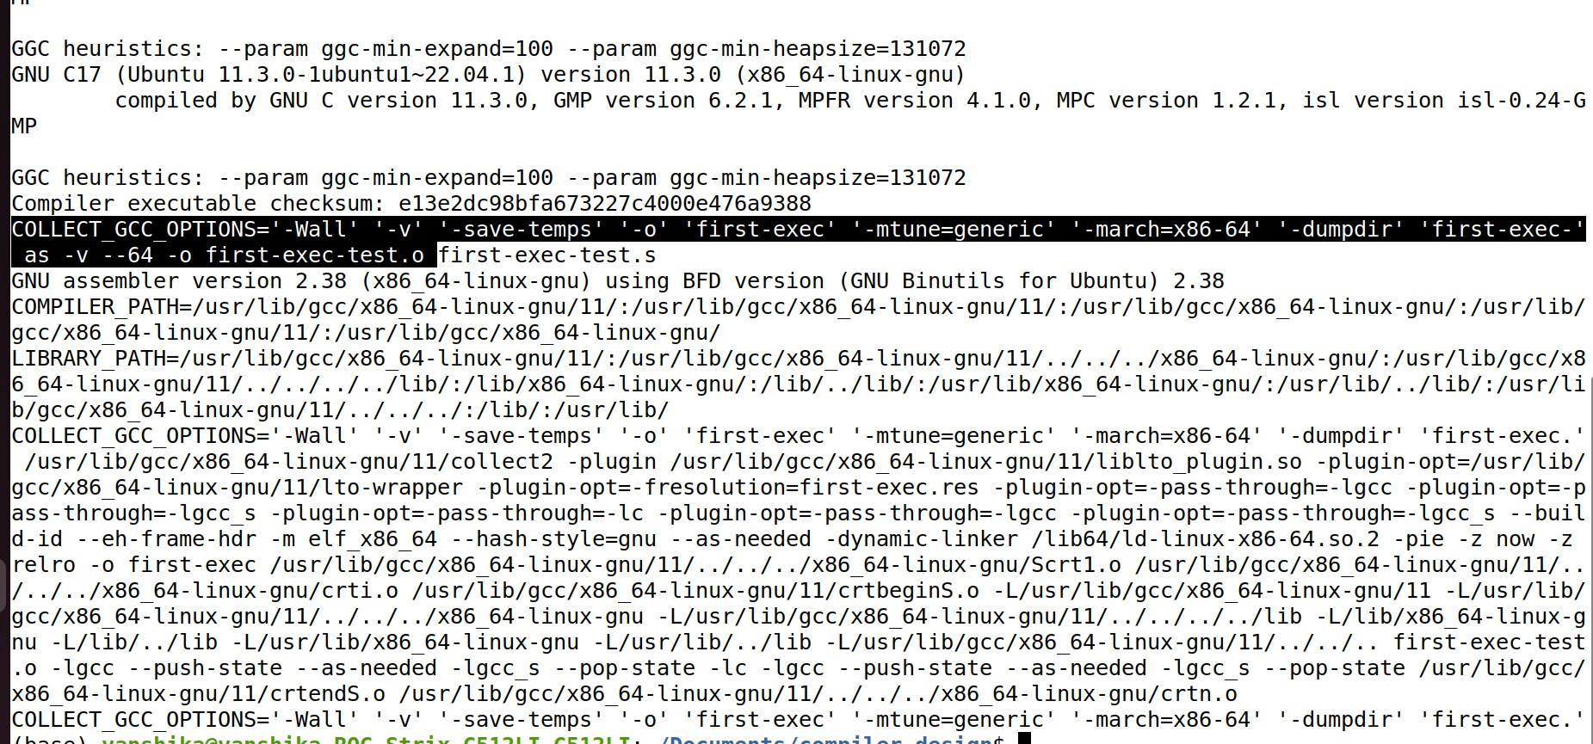

Contents of first-exec-test.o

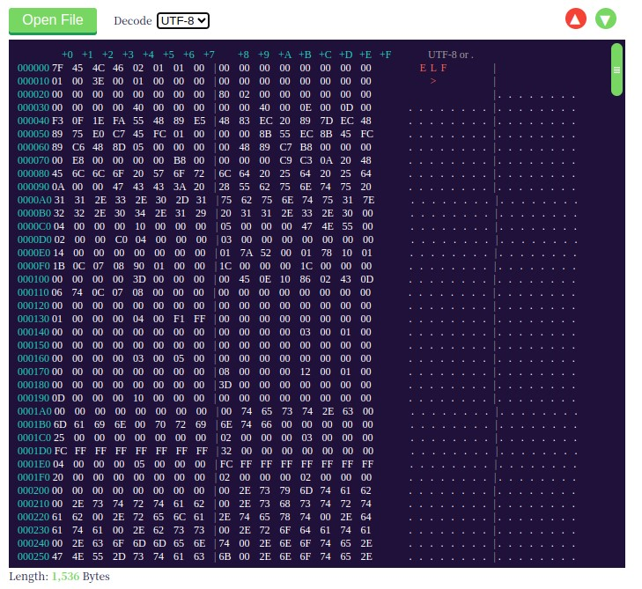

Linker/Loader: the object file is finally converted to executable which runs the code and shows the final output.

ii) Programming Language Swift

Program written is:  
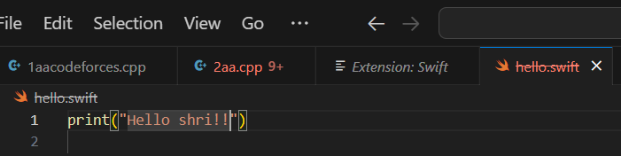

Intermediate Steps in compilation are:

1. **Parser**. To print the AST (**abstract syntax tree**) after parsing:

swiftc -dump-ast -O hello.swift

Output:

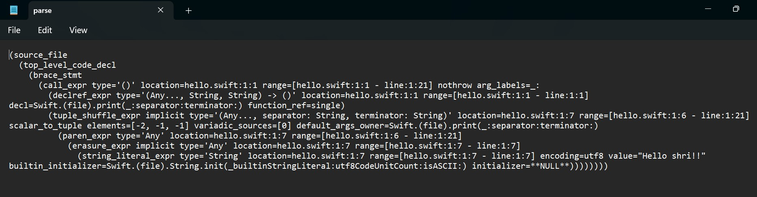

1. **SILGen**. To print the SIL (Swift intermediate language) immediately after SILGen:

swiftc -emit-silgen -O hello.swift

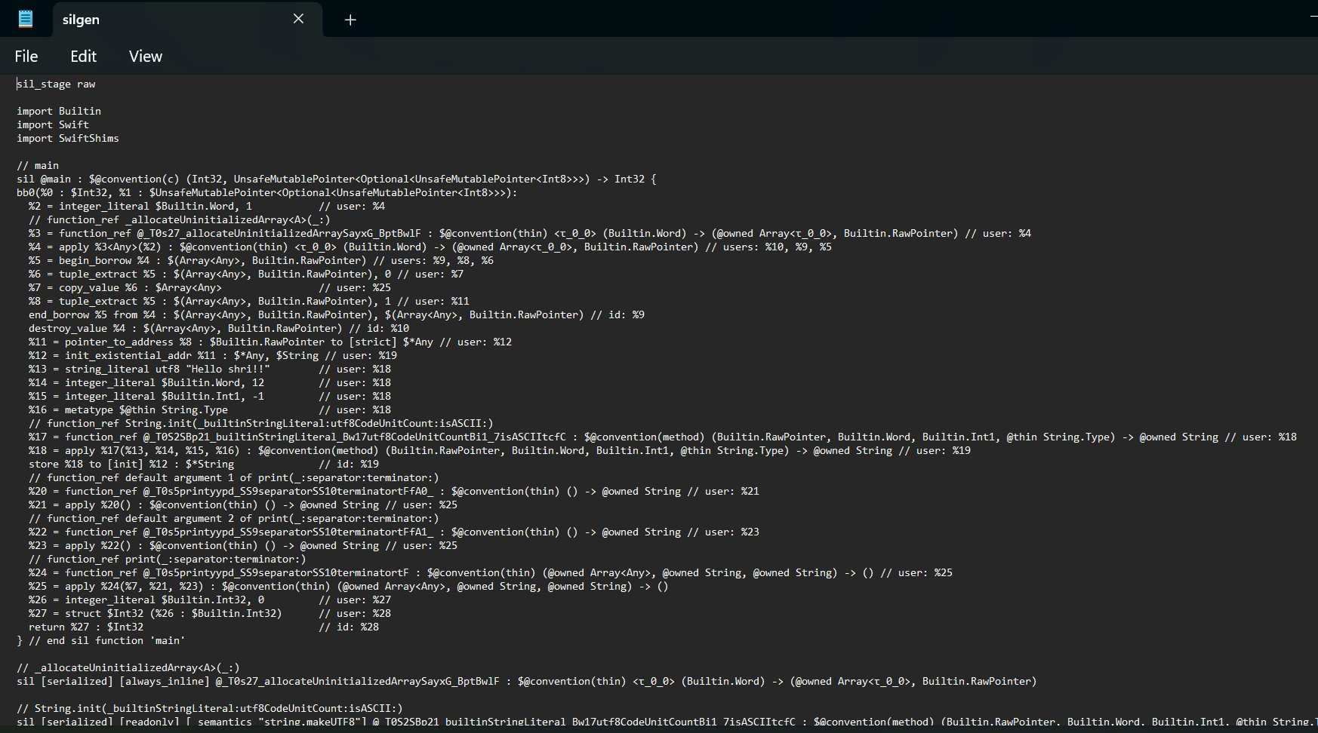

1. **Performance SIL passes**. To print the SIL after the complete SIL oprimization pipeline:

swiftc -emit-sil -O hello.swift

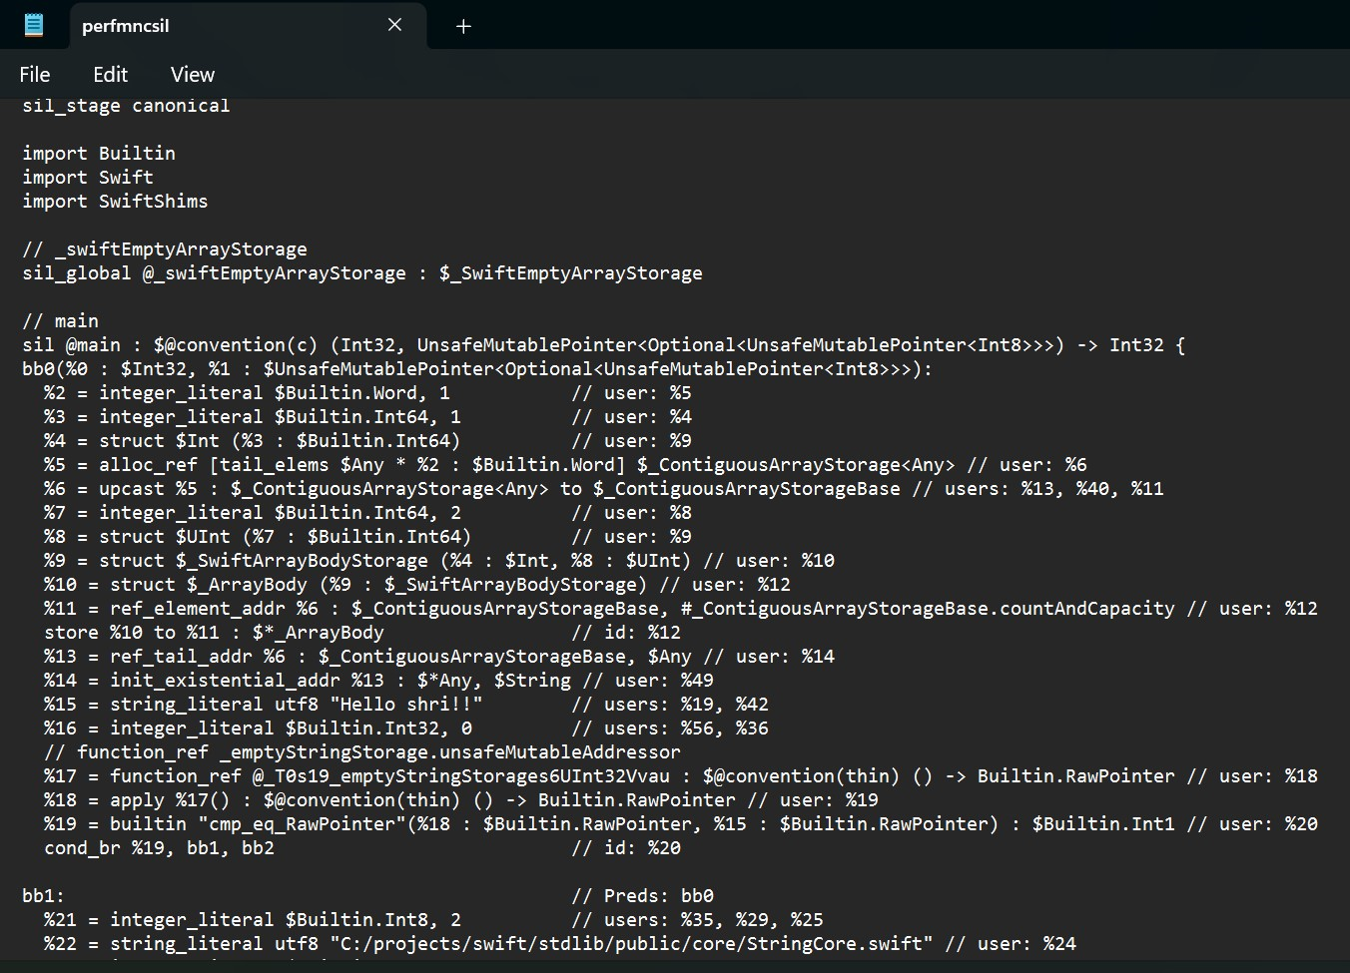

1. **IRGen**. To print the LLVM (*Low Level Virtual Machine*) IR (Intermediate representation) after IR generation:

swiftc -emit-ir -Xfrontend -disable-llvm-optzns -O hello.swift

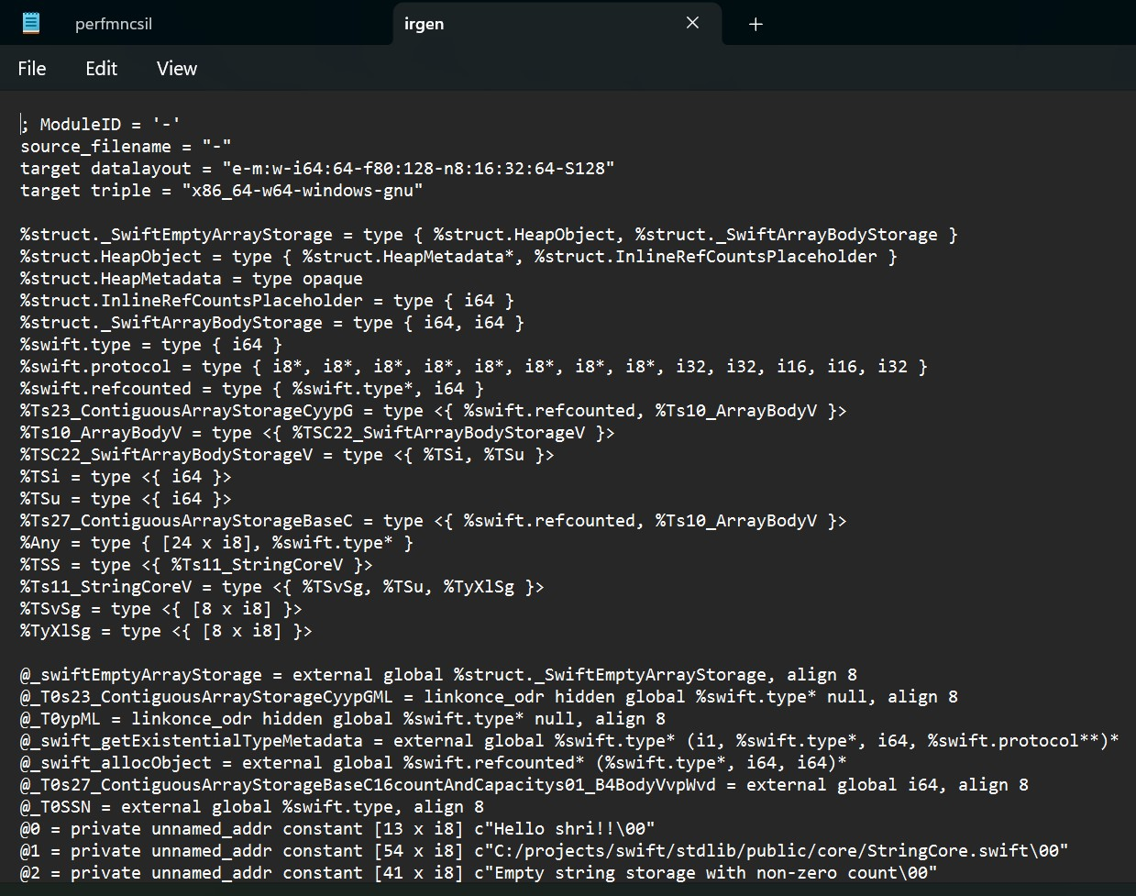

1. **LLVM passes**. To print the LLVM IR after LLVM passes:

swiftc -emit-ir -O hello.swift

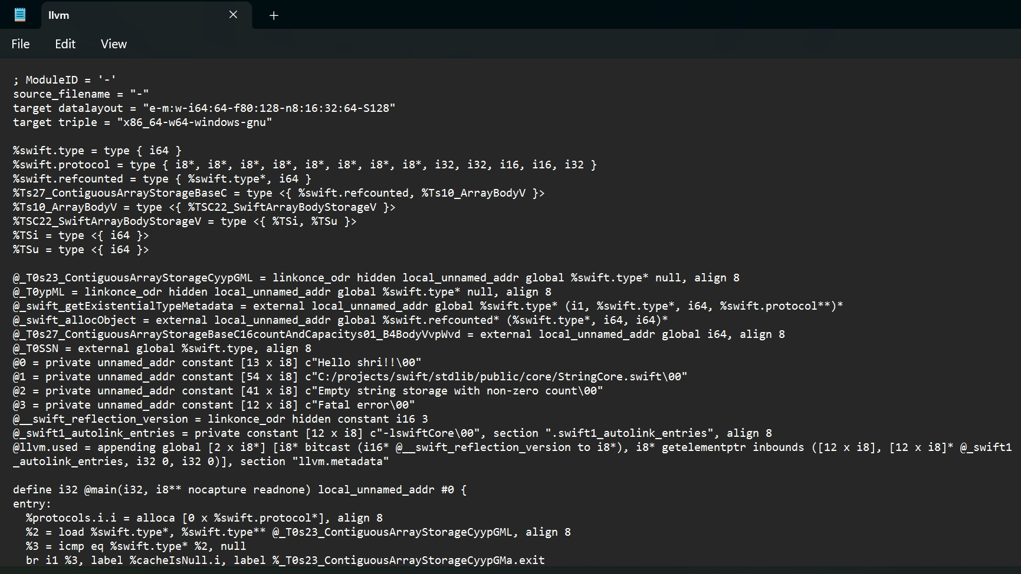

1. **Code generation**. generates the assembly code and finally produces lower-level code (.o, executable…). To view the assembly:

swiftc -S -O hello.swift

